entity relationship diagram (ERD)

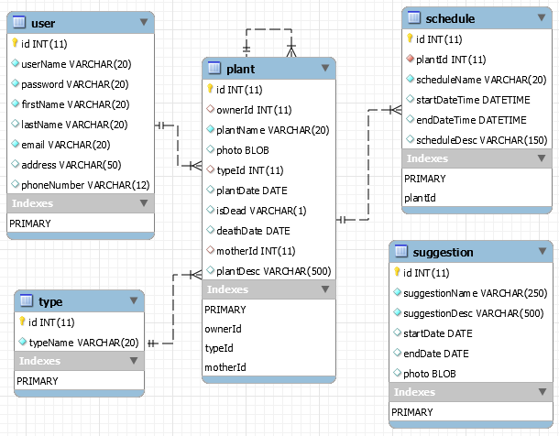

Figure 1: Entity Relationship Diagram (ERD) for Pet Your Plant